**Operational Amplifier II**

**Lab 13**

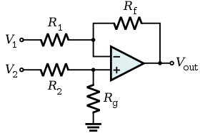

ECE 1101 Lab, Section 6

Date: Thursday, November 21st, 2019

Kyler Martinez, Daniel Tan

Equipment Used In The Experiment:

* Keysight Function/Arbitrary Waveform Generator 10Hz
  + Make/Model: 33210A
  + Serial Number: MY48017338
* Keysight InfiniiVision Digital Storage Oscilloscope 200 MHz
  + Make/Model: DSOX2022A
  + Serial Number: MY56041108
* Keysight Triple Output DC Power Supply
  + Make/Model: E3630A
  + Serial Number: MY56186189
* Keysight 4 ½ Digital Display Multimeter
  + Make/Model: U3401A
  + Serial Number: MY56150032
* Lab-Volt Power Supply
  + Make/Model: 1224 AC/Dual DC Power Supply
  + Serial Number: N/A

Materials Used In The Experiment:

* Breadboard
* 741 Operational Amplifier
* Four 10kΩ resistor
* 220kΩ resistor
* 330k Ω resistor
* Two 47k Ω resistor
* Four 100k Ω resistor

Objective:

The objective of this lab is to design and validate the operation of a difference amplifier.

Background Theory:

When using general values, output is a combination of V1 & V2. For difference amplifiers, if R2=R1 and R3=Rf then the Vo will be Vo=(Rf/R1)(V2-V1)

Procedure:

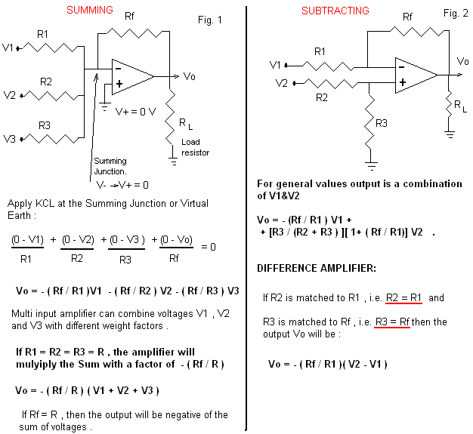Build the circuit with the subtracting amplifier, set the +/-Vcc power supply to +/-15V, R1/R2=100kΩ, R3/Rf=47kΩ, and RL=10kΩ. Then, connect a common voltage source to the V1=V2 inputs. Make the source vary from -10V to +10V to measure the output range. Next, apply the voltages V2=5V and V1=-4V. Measure the Vo and compare this value to what you would calculate from the equations from the background theory. Connect and disconnect RL and see if this changes the result. Set V2=0, then the signal generator to 4Vpp at 1kHz and apply it as the input V1. Observe V1 and Vo on the oscilloscope and observe and record the phase angle and waveforms. Then, measure the gain. Finally, set V1=0 and apply the same signal from V2. Observe Vo and V2 on Ch1 and CH2 of the oscilloscope and take pictures of these.

Data:

We found that by varying the common voltage from -10 to +10 for V1 and V2 we got a range of 24.8 mV < Vo < 28.45 mV.

When V2= 5V and V1 = -4V Vo was measured to be 4.2473 V and was calculated to be 4.23 V.

When we grounded V2 and used a sine wave of 4V Vpp and we got a positive gain of -.469 V and when we grounded V1 we got a positive gain of .467 V. The gain is found by Vo/Vin.

Oscilloscope of the output and input when V2 is grounded: (Green is Vo and yellow is V1)

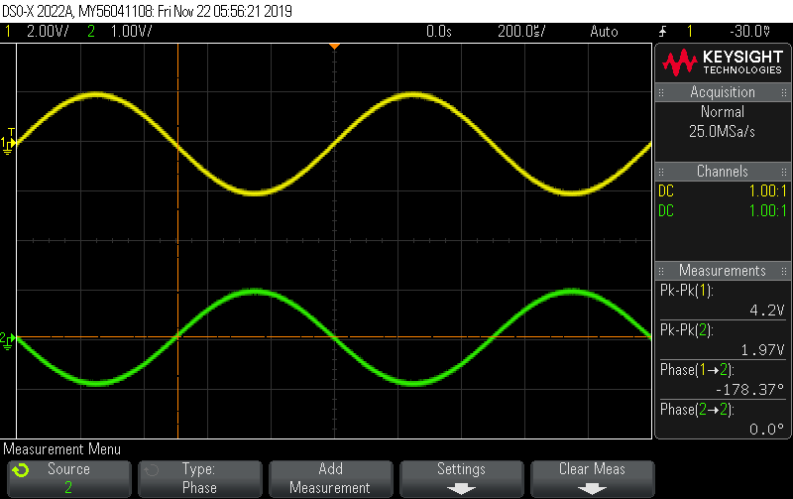

Oscilloscope of the output and input when V1 is grounded: (Green is Vo and yellow is V2)

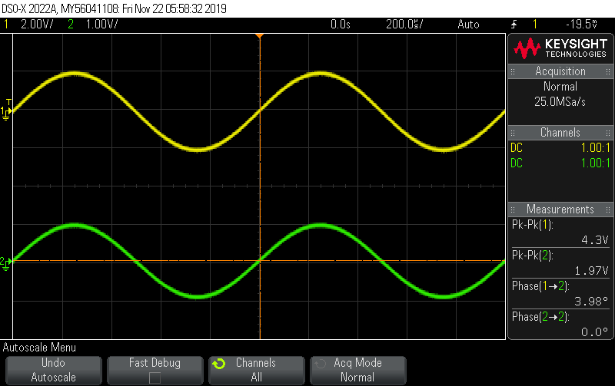

Conclusion:

Our range for the common voltage source isn’t zero more than likely due to the fact that the operational amplifier doesn’t work perfectly and a small difference can be magnified since there’s a small chance of the voltage changing slightly between both inputs causing a difference between the two. When we set V2= 5V and V1 = -4V, there was a .4089% discrepancy between the calculated output and the measured output. RL didn’t have an effect on our circuit due to the fact that RL doesn’t directly include the input voltages or output directly. We calculated the positive gain to be .47 while our measured value was .467 which yields a .63% discrepancy and our negative gain came out to be -.469 while compared to the calculated .47 gain, it yields a .21 % discrepancy. Our two measured values should be opposites of each other and using the average as a comparing value there is an approximate .43% discrepancy. These discrepancies can be attributed to the fact that voltage can fluctuate and result in minor discrepancies. Another reason is discrepancies could arise is that the operational amplifiers don’t work perfectly, and the resistors aren’t at their ideal values which can result in small discrepancies that we saw in our results.